The Arabic Alphabet - الحروف العربية
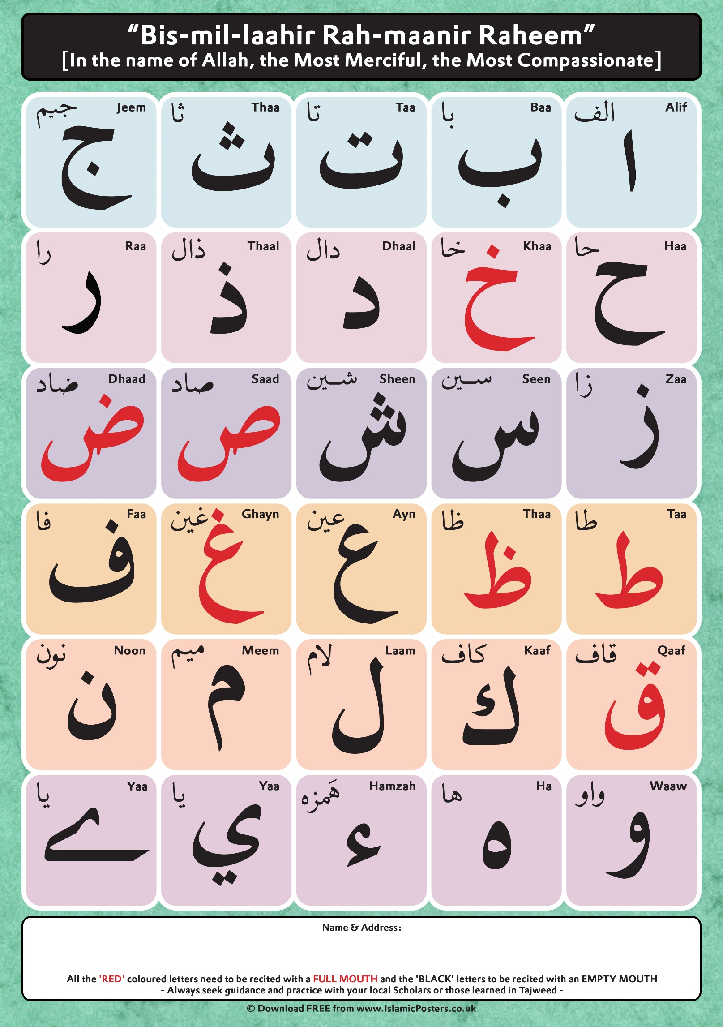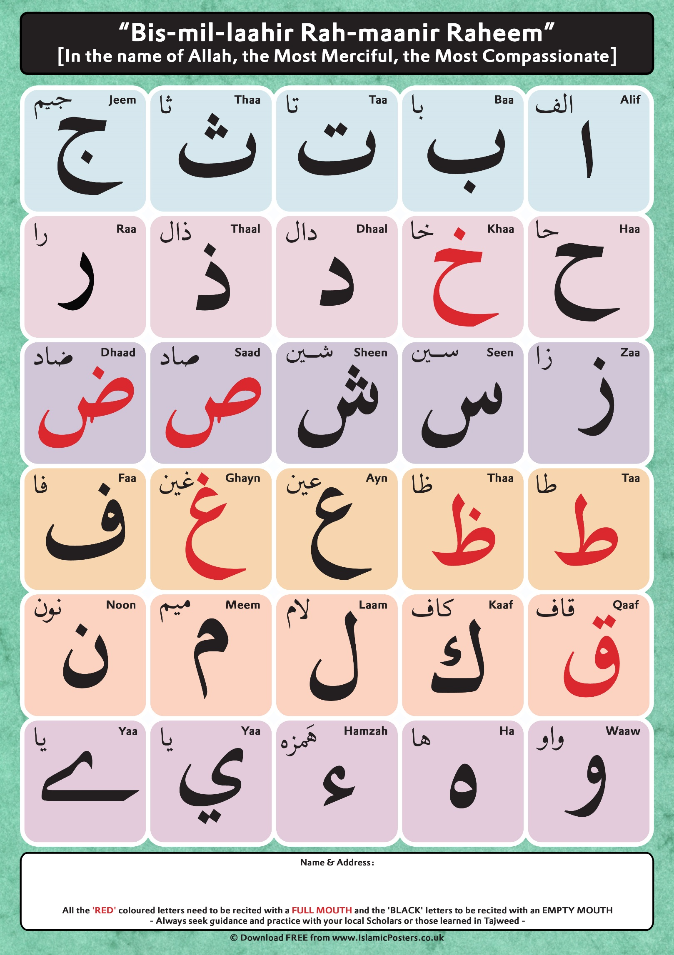
- Twenty nine letters
- Alif has different roles
- Heavy letters
- Light letters
- Naughty letters
Diacritical Marks – علامات التشكيل
Al Fat-hah | الفتحة | Short vowel | a | َ
Al Khasrah | الكسرة | Short vowel | i | ِ
Ad Dhammah | الضمة | Short vowel | u | ُ
As Sakoon | السكون | Half letter |  | ْ
Ash Shaddah | الشدة | Double letter emphasis |  | ّ
Al Madd (alif) | المد | Long vowel | aa | آ

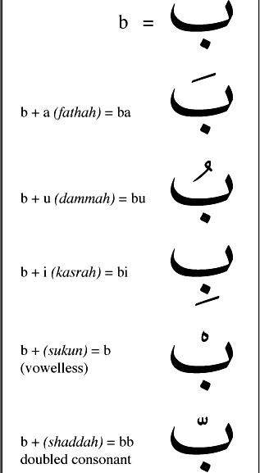
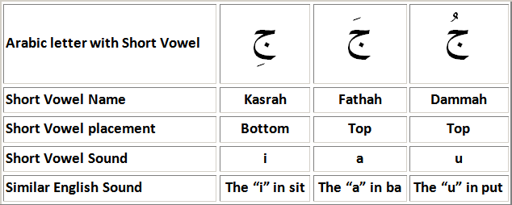

Meeting and Greeting
التَّحِيَّةُ وَالتَّعَارُفُ
Learning how to greet and introduce yourself
Hi/Hello – Ahlan wa sahlan!

Hi/Welcome - Marhaban!

Peace be upon you – Assalaamu Alaikum!

Good Morning – Sabaahu Al khayr

Hello (phone) – Hallo

What is your name? – Maa ‘smoka / ‘smoki

My name is – Ismee Jack

Who are you? - Man anta/anti?

I am Susan – Anaa Susan

Bye – Ma’ Assalaamah

Hi/Hello – أهلاً وسهلاً
Hi/Welcome - مرحباً
Peace be upon you – السلام عليكم
Good Morning – صباح الخير
Hello (phone) - هالو

What is your name? – ما اِسمكَ/ اِسمكِ؟
My name is – اِسمي جاك
Who are you? - من أنتَ/أنتِ
I am Susan - أنا سوسن

Bye – مع السّلامة

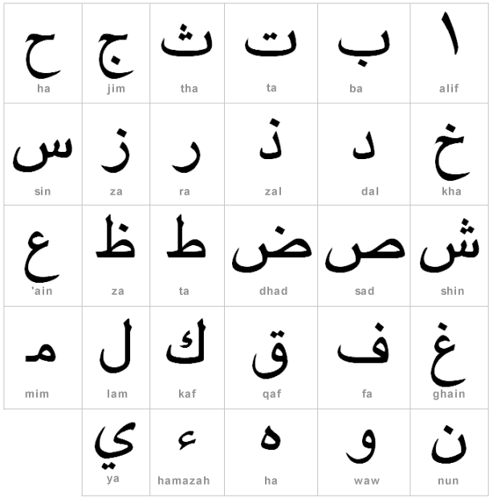
Practice writing the Arabic alphabet by writing over the letters beginning with the right

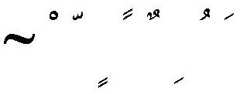

Name the following letters
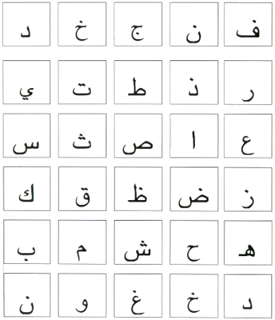

Draw the correct vowel on/under the letters to spell the word



